EE/CE 321L / 371L
Computer Architecture Lab

Course Project Report
Assembly-Level Execution on Integrated RISC-V Processor

Link to Github Repository:
https://github.com/myrahhussain/CA_Labs_MyrahHussain_RomaisaShazad

Submitted By:
Romaisa Shazad
rb10107

Myrah Hussain
mh10074

1. Introduction

This report documents the course project for Computer Architecture Lab, which focuses on integrating RISC-V assembly language programming with a fully functional single-cycle RISC-V processor implemented on an FPGA (Basys3). The project builds directly on work completed in Lab 10 (assembly programming) and Lab 11 (single-cycle processor integration), requiring us to load, execute, and verify assembly programs on real hardware and demonstrate visible output through LEDs and a seven-segment display.

1.1 Key Modules
The integrated processor is composed of the following hardware modules:

Module | Description
FpgaTop | Top-level FPGA wrapper. Manages clock division, button debouncing, mode toggling (debug/run), and routes all I/O signals between the processor and the physical board peripherals.
TopLevelProcessor | Structural top that wires every datapath and control submodule together, exposes debug signals, and drives led_out / led_out32.
ProgramCounter (PC) | 32-bit register that holds the current instruction address, updated every clock cycle with nextPC.
pcAdder | Combinational adder that produces PC+4 for sequential execution.
instructionMemory | 64-word synchronous ROM initialised from a .hex file. Word-addressed by PC[7:2].
MainControl | Decodes the 7-bit opcode and drives control signals
ALUControl | Produces the 4-bit ALUControl signal from ALUOp, funct3, and funct7.
ALU | 32-bit arithmetic-logic unit. Supports ADD, SUB, AND, OR, XOR, SLT, shifts, and passes back Zero and LessThan flags.
RegisterFile | 32 x 32-bit register bank. x0 is hardwired to zero. Synchronous write, combinational read.
immGen | Generates sign-extended 32-bit immediates for I-, S-, B-, J-, and U-type instructions.
DataMemory | Byte-addressable data RAM; also routes ledData from address 0x000 to the LED peripheral.
AddressDecoder | Decodes ALUResult[9:8] to route memory accesses to data memory, the LED register, or the switch peripheral.
switches | Memory-mapped read-only peripheral at address 0x200 that exposes the 16 board switches to the processor.
leds | Latches the 16-bit (and 32-bit) LED output written by the assembly program.
clkDivider | Divides the 100 MHz board clock to ~0.5 Hz for single-step visibility on hardware.
debouncer | 20-bit timer debouncer for each physical push-button.
SevenSegmentDriver / Decoder | Time-multiplexed 4-digit seven-segment display driver with a BCD converter for decimal output.
BinaryToBCD | Double-dabble converter for displaying 16-bit binary values as decimal digits.

1.2 System Integration
All modules are connected in a single-cycle datapath following the standard RISC-V execute path: Fetch → Decode → Execute → Memory → Write-Back. The FPGA top module sits above the processor and handles board-level concerns: a 26-bit clock divider slows execution so each instruction is visible on the LEDs, four debounced push-buttons control debug/run mode, ALU display mode, 32-bit output mode, and a master reset. Memory-mapped I/O at addresses 0x000 (LED write) and 0x200 (switch read) provides the hardware interface used by all assembly programs in this project.

2. Task A – Base Assembly Program Execution

Task A requires loading the RISC-V assembly program developed in Lab 10 into the integrated processor and demonstrating correct execution on the Basys3 FPGA board. The program implements a hardware countdown timer: it reads a value from the physical switches, then counts that value down to zero, displaying the current count on the 16 LEDs in real time. Only the core RV32I instructions already supported by the base processor are used in this task.

2.1 Program Description
The program is structured around two logical sections: an IDLE/READ polling loop that holds the LED output at zero while waiting for a non-zero switch value, and a RUN_COUNTER subroutine that performs the decrement loop. The stack is used inside the subroutine to preserve registers across the procedure call. All control flow is achieved using BEQ, ADD with x0, and SW/LW for memory-mapped I/O.

Register Allocation
x2 (sp) | Stack pointer – initialised to 128; used for saving/restoring x1 and x12 across the subroutine call.
x8 | LED base address (0x000) – memory-mapped address written by SW to drive the LEDs.
x9 | Switch base address (0x200 = 512 decimal) – memory-mapped address read by LW to sample the switches.
x10 | Snapshot of the switch value; passed as the countdown start argument to RUN_COUNTER.
x11 | Temporary: holds the raw LW result from the switch port for the zero-test in READ.
x12 | Countdown counter – initialised to x10 inside the subroutine, decremented each LOOP iteration, written to LEDs.
x1 (ra) | Return address – written by the call mechanism and preserved on the stack inside the subroutine.

2.2 Assembly Source
.globl main
.text
main:
addi x2, x0, 128 # sp = 128 (stack base in data memory)
addi x8, x0, 0 # LED_ADDR = 0x000
addi x9, x0, 512 # SW_ADDR = 0x200

IDLE:
sw x0, 0(x8) # clear LEDs

READ:
lw x11, 0(x9) # x11 = current switch value
beq x11, x0, READ # if zero, keep polling
add x10, x11, x0 # copy switch value into x10 (argument)
jal x1, RUN_COUNTER # call subroutine
beq x0, x0, IDLE # return to IDLE

RUN_COUNTER:
addi x2, x2, -8 # allocate 2 words on stack
sw x1, 4(x2) # push return address
sw x12, 0(x2) # push x12 (callee-saved)
add x12, x10, x0 # x12 = countdown start value

LOOP:
sw x12, 0(x8) # display current count on LEDs
beq x12, x0, DONE # exit when count reaches zero
addi x12, x12, -1 # decrement
beq x0, x0, LOOP # loop back (unconditional via BEQ x0,x0)

DONE:
sw x0, 0(x8) # clear LEDs
lw x12, 0(x2) # pop x12
lw x1, 4(x2) # pop return address
addi x2, x2, 8 # deallocate stack frame
jalr x0, 0(x1) # return to caller

2.3 Execution Flow
The program follows the sequence below for every switch-to-countdown cycle:

- Initialisation (main): The stack pointer is set to address 128, the LED address register is set to 0x000, and the switch address register is set to 0x200 (512 decimal).
- IDLE: SW x0, 0(x8) writes zero to the LED memory-mapped address, blanking the display before the next read cycle begins.
- READ: LW x11, 0(x9) loads the current switch value. BEQ x11, x0 loops back while the value is zero. Once any switch is set, ADD x10, x11, x0 copies it into the argument register x10.
- RUN_COUNTER entry: The stack frame is opened by ADDI x2, x2, -8, then x1 (return address) and x12 (callee-saved) are pushed to memory. ADD x12, x10, x0 loads the countdown start value.
- LOOP (countdown): Each iteration writes x12 to the LEDs via SW, checks for zero using BEQ x12, x0, decrements with ADDI x12, x12, -1, and loops back using BEQ x0, x0 (always-taken branch).
- DONE: LEDs are cleared, x12 and x1 are restored from the stack, the frame is deallocated with ADDI x2, x2, 8, and execution returns to the caller.

2.4 How the Single-Cycle Processor Works

Every instruction in this processor completes in exactly one clock cycle. There are no pipeline stages — fetch, decode, execute, memory access, and write-back all happen combinationally within a single clock period. Only the sequential elements (PC, register file, data memory, LED latch) update on the rising edge.

Stage 1 — Instruction Fetch
The ProgramCounter register holds the current 32-bit byte address. On every rising clock edge it updates to nextPC. The instructionMemory module is a 64-word ROM initialised from a .hex file; it is purely combinational — given PC[7:2] as the word index it immediately outputs the 32-bit instruction. The pcAdder simultaneously computes PC+4 for sequential execution.

Stage 2 — Decode and Register Read
The 32-bit instruction is decoded in parallel by three units:
MainControl inspects instruction[6:0] (opcode) and drives all control signals: RegWrite, ALUSrc, MemRead, MemWrite, MemtoReg, Branch, ALUOp, Jump, and Jalr — all purely combinational.
immGen reconstructs the correct sign-extended immediate for the instruction type: 12-bit for I/S-type, 13-bit for B-type, 21-bit for J-type, 20-bit upper for U-type.
The RegisterFile reads rs1 (instruction[19:15]) and rs2 (instruction[24:20]) combinationally. x0 is hardwired to zero.

Stage 3 — Execute (ALU)
A 2:1 mux (u_aluSrcMux) selects the ALU's B input: ReadData2 for R-type, or the immediate for I/S/B/U/J-type, controlled by ALUSrc. ALUControl decodes ALUOp with funct3 and funct7 to produce the 4-bit operation select. The ALU computes its result combinationally and outputs ALUResult, Zero, and LessThan. The ripple-carry chain through the 32 ALU slices is the design's critical path.

Stage 4 — Memory Access and Address Decoding
ALUResult becomes the memory address. The AddressDecoder inspects bits [9:8]: address 0x000 targets DataMemory and simultaneously feeds ledData to the LED latch; address 0x200 asserts switchReadEnable so the switch module returns sw_in on the data bus. A mux (u_muxSwitchOrMem) selects between the two read sources.

Stage 5 — Write-Back and Next-PC Selection
Two cascaded muxes select WriteBackData: the first chooses between ALUResult and memory read data (MemtoReg); the second overrides with PCplus4 when Jump or Jalr is asserted, saving the return address into rd. The write occurs on the next rising edge if RegWrite=1 and rd is not x0.
For next PC: PCSrc = (Branch AND takeBranch) OR Jump. A first mux chooses between PC+4 and branchTarget based on PCSrc. A second mux overrides with ALUResult when Jalr=1. This output is nextPC, which the PC register loads on the rising edge — completing the single cycle.

Clock Division and Debug Mode
The 100 MHz board clock is divided by a 26-bit counter (toggle at 24,999,999) to approximately 0.5 Hz, making each instruction visible as a distinct LED change. Debug mode (BTNU) gates the slow clock with switch[15], allowing single-step execution. All buttons pass through a 20-bit debouncer.

Stage | Key Module(s) | Type | Output
Fetch | ProgramCounter, instructionMemory, pcAdder | PC: sequential; ROM+adder: combinational | instruction, PCplus4
Decode | MainControl, immGen, RegisterFile | All combinational | Control signals, imm, ReadData1/2
Execute | ALUControl, ALU, mux2 | All combinational | ALUResult, Zero, LessThan
Memory | AddressDecoder, DataMemory, switches | Comb. decode; RAM write: sequential | MemReadData or sw_in
Write-Back | mux2 x2, RegisterFile | Muxes: comb; RegFile write: sequential | WriteBackData written to rd
Next PC | branchAdder, mux2 x2, ProgramCounter | Adder+muxes: comb; PC: sequential | nextPC loaded on clock edge

Datapath Trace: SW x12, 0(x8) — Writing Countdown to LEDs
This instruction is the heart of Task A's countdown display. Here is its full datapath trace:

Stage | What Happens
Fetch | PC drives instructionMemory. The 32-bit SW encoding is output combinationally.
Decode | MainControl sees opcode 0100011 (S-type): asserts MemWrite=1, ALUSrc=1, RegWrite=0, Branch=0. immGen produces S-type immediate = 0 (no offset).
Register Read | RegisterFile reads rs1=x8 (value 0x000, LED base address) and rs2=x12 (current countdown value).
Execute | ALUSrc=1 so mux selects the immediate (0). ALUOp=00 so ALUControl drives ADD. ALU computes 0x000 + 0 = 0x000.
Memory/I/O | ALUResult=0x000. AddressDecoder bits[9:8]=00: asserts LEDWrite=1, leaves dataMemWrite=0. The leds module latches ReadData2 (x12 countdown value) on the next rising edge.
Write-Back | RegWrite=0 — no register write. LED output now shows the countdown value.

2.4 Memory-Mapped I/O
The AddressDecoder module inspects bits [9:8] of the ALU result to route memory accesses. Address 0x000 (bits [9:8] = 00) targets data memory and simultaneously feeds ledData to the LED latch peripheral. Address 0x200 (bits [9:8] = 10) asserts switchReadEnable, causing the switch module to place the 16-bit switch value on the read-data bus. Ordinary LW and SW instructions at these addresses are sufficient — no special I/O instructions are required.

2.5 Instructions Used
Instruction | Type | Purpose in Program
ADDI | I-type | Initialise sp, LED address, and switch address; decrement x12 by 1 each loop iteration; adjust stack pointer.
SW | S-type | Write countdown value or zero to LED memory-mapped address; push x1 and x12 onto the stack.
LW | I-type | Read switch value from memory-mapped switch address; pop x1 and x12 from the stack.
BEQ | B-type | Poll for non-zero switch value; detect countdown reaching zero; implement unconditional back-edges via BEQ x0, x0.
ADD | R-type | Copy register values: x11 into x10, and x10 into x12, using ADD rd, rs1, x0.

2.6 Simulation Results
The testbench (tb_TaskA) applies the following stimulus sequence:
- Reset is asserted for 4 clock cycles to initialise all registers and the program counter to zero.
- Switches are held at 0x0000 for 20 cycles to verify the READ polling loop keeps LEDs at zero.
- Switches are set to 0x0005 (decimal 5). The processor reads the value, enters RUN_COUNTER, and led_out transitions 5 → 4 → 3 → 2 → 1 → 0 on successive clock cycles.
- Switches are cleared to 0x0000 and the LED is confirmed to remain at zero (IDLE state).

The simulation waveform confirms correct instruction sequencing: PC advances by 4 each cycle, BEQ branch targets resolve correctly, the stack pointer tracks allocations and deallocations, and led_out shows the complete 5-to-0 countdown.

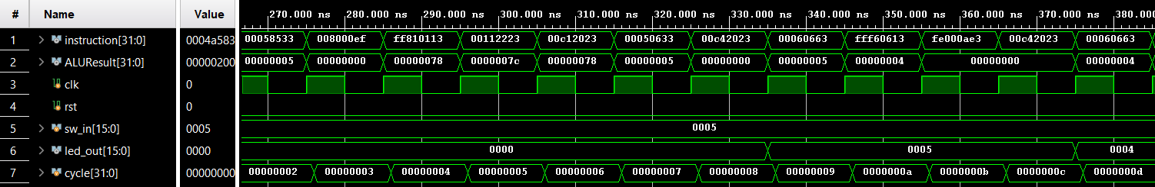
Figure 1:Zoomed out to show PC updating and instructions in hex on top

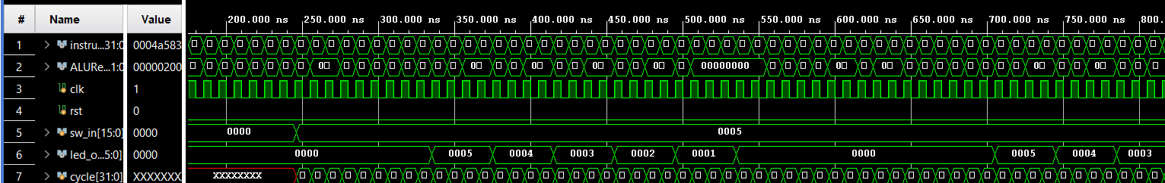
Figure 2: Task A simulation waveform – countdown from 5 to 0
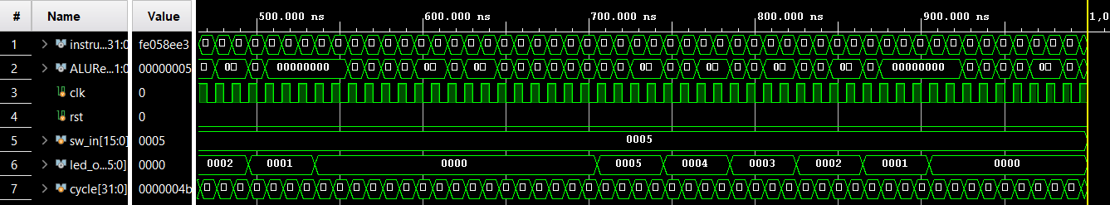Figure 3: Task A simulation waveform – countdown from 5 to 0

2.7 Hardware Demonstration
After synthesis and implementation in Vivado the bitstream was programmed onto the Basys3. The processor ran at the divided clock rate (~0.5 Hz) so individual LED changes were clearly visible. Setting any non-zero switch value caused the LED bar to count down to zero, matching simulation exactly. Debug mode (BTNU) was used to single-step through instructions and verify ALU results and control signals on the seven-segment display at each step.

Resource Utilisation — Task A
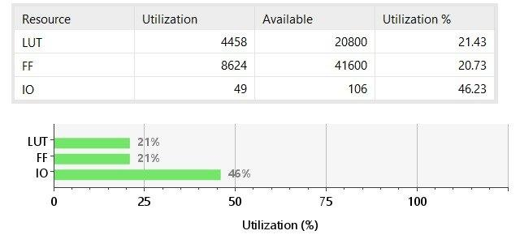
Figure 3: Task A post-implementation utilisation. LUT: 4458/20800 (21.43%), FF: 8624/41600 (20.73%), IO: 49/106 (46.23%).

The 21% LUT usage reflects the 64x32-bit instruction ROM (mapped to LUTs), 32x32-bit register file, ALU, control logic, debouncing timers, and seven-segment display. The 46% IO usage covers 16 switches + 16 LEDs + 7 seg cathodes + 4 anodes + 5 buttons + 1 clock = 49 pins.

Design Timing Summary — Task A
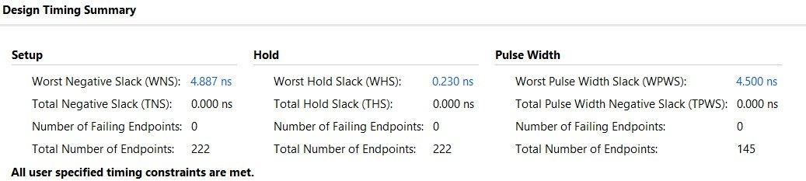
Figure 4: Task A timing summary. WNS=4.887ns, TNS=0ns, 0 failing endpoints out of 222. All constraints met.

WNS=4.887ns means nearly 5ns of setup margin on the 10ns (100MHz) clock constraint. Since the processor runs at 0.5Hz, timing closure is trivially satisfied. Zero failing endpoints confirms no setup or hold violations.

3. Task B – Instruction Extension

Task B extends the base processor with three new RISC-V instructions of different types: BGE (B-type branch), JAL (J-type jump), and JALR (I-type jump-and-link register). Each instruction required additions to MainControl, the immediate generator, ALUControl, and the PC-selection logic. A new assembly program demonstrating all three instructions is loaded and verified in simulation and on hardware.

3.1 New Instructions

Instruction 1 – BGE (Branch if Greater or Equal, B-type)
BGE branches to PC + imm when rs1 >= rs2 (signed). It reuses the existing branch datapath but requires the LessThan flag from the ALU: the branch is taken when LessThan is low (i.e., rs1 is NOT less than rs2).

Field | Value
Opcode | 1100011 (shared with all B-type branches)
funct3 | 101
Operation | if (rs1 >= rs2) PC = PC + sign_extend(imm)
Flags used | LessThan (from ALU, already present in base processor)

Datapath changes – BGE
- MainControl: the BRANCH opcode case (7'b1100011) was added, setting Branch=1, ALUOp=2'b01, RegWrite=0, and all memory signals to 0.
- takeBranch logic in TopLevelProcessor: funct3=101 case added — branch taken when ~LessThan. BGE was already partially wired; this formally completes it.
- immGen: B-type immediate reconstruction was already present; no change needed.
- ALUControl: ALUOp=01 drives a SUB operation so the LessThan flag is computed correctly.

Instruction 2 – JAL (Jump and Link, J-type)
JAL unconditionally jumps to PC + imm and writes PC+4 into the destination register (used as the return address for subroutine calls). It is the only J-type instruction in RV32I.

Field | Value
Opcode | 1101111
Operation | rd = PC + 4; PC = PC + sign_extend(imm)
Immediate | J-type: 20-bit signed offset, LSB hardwired to 0 (2-byte aligned)
Write-back | PC+4 written to rd via the Jump mux in the write-back path

Datapath changes – JAL
- MainControl: opcode 7'b1101111 case added — sets Jump=1, RegWrite=1, ALUSrc=0, all memory signals 0.
- immGen: J-type immediate already implemented (bits [31], [19:12], [20], [30:21], 0).
- branchAdder output fed into the PC mux; PCSrc = Branch & takeBranch | Jump already combines both.
- Write-back mux (u_wbMux2): sel = Jump | Jalr selects PCplus4 as WriteBackData so rd receives the return address.

Instruction 3 – JALR (Jump and Link Register, I-type)
JALR jumps to rs1 + imm (with bit 0 cleared) and writes PC+4 into rd. It is used to return from subroutines (JALR x0, 0(x1)) and for indirect calls.

Field | Value
Opcode | 1100111
funct3 | 000
Operation | rd = PC + 4; PC = (rs1 + sign_extend(imm)) & ~1
Immediate | I-type: 12-bit signed, sign-extended to 32 bits
Write-back | PC+4 written to rd; ALUResult (rs1+imm) drives the second PC mux

Datapath changes – JALR
- MainControl: opcode 7'b1100111 case added — sets Jalr=1, RegWrite=1, ALUSrc=1 (use immediate), ALUOp=2'b00 (ADD).
- immGen: I-type immediate (sign_extend(inst[31:20])) already handled; no change.
- PC mux (u_pcMux2): sel = Jalr selects ALUResult (rs1 + imm) as nextPC, overriding the branch/sequential result.
- Write-back mux (u_wbMux2): sel = Jump | Jalr already routes PCplus4 to WriteBackData for rd.

3.2 Control Signal Summary
Signal | BGE | JAL | JALR
RegWrite | 0 | 1 | 1
ALUSrc | 0 | 0 | 1
MemRead | 0 | 0 | 0
MemWrite | 0 | 0 | 0
MemtoReg | 0 | 0 | 0
Branch | 1 | 0 | 0
Jump | 0 | 1 | 0
Jalr | 0 | 0 | 1
ALUOp | 01 | 00 | 00

3.3 Datapath Modifications for New Instructions

The base processor required four targeted changes to support BGE, JAL, and JALR. No existing paths were removed — each change is additive.

(a) takeBranch Logic — adding BGE (funct3=101)
The base processor only decoded BEQ and BNE in its branch decision logic. BGE requires the LessThan flag rather than the Zero flag. The takeBranch wire was extended:

// Before (base):
wire takeBranch = (instruction[14:12] == 3'b000) ? Zero // BEQ
: (instruction[14:12] == 3'b001) ? ~Zero // BNE
: 1'b0;

// After (BGE added):
wire takeBranch = (instruction[14:12] == 3'b000) ? Zero // BEQ
: (instruction[14:12] == 3'b001) ? ~Zero // BNE
: (instruction[14:12] == 3'b101) ? ~LessThan // BGE
: 1'b0;

BGE is taken when rs1 is NOT less than rs2, which is ~LessThan. No ALU changes were needed — LessThan was already generated by the ALU's SUB path.

(b) MainControl — three new opcode cases

Instruction | Opcode | Signals asserted | Effect
BGE (branch) | 1100011 | Branch=1, ALUOp=01 | Existing branch path used; takeBranch now checks ~LessThan for funct3=101
JAL | 1101111 | Jump=1, RegWrite=1 | Jump ORed into PCSrc so Mux1 selects branchTarget; Mux2 selects PCplus4 for rd
JALR | 1100111 | Jalr=1, RegWrite=1, ALUSrc=1 | Mux2 selects ALUResult (rs1+imm) as nextPC; PCplus4 written to rd

(c) PC Mux Chain — JAL and JALR target selection
// Mux 1 — branch or sequential
wire PCSrc = (Branch & takeBranch) | Jump;
mux2 u_pcMux1(.in0(PCplus4), .in1(branchTarget), .sel(PCSrc), .out(pcBranchOrSeq));

// Mux 2 — JALR overrides with ALU result (rs1+imm)
mux2 u_pcMux2(.in0(pcBranchOrSeq), .in1(ALUResult), .sel(Jalr), .out(nextPC));

JAL: Jump=1 so PCSrc=1, Mux1 selects branchTarget (PC+imm), Mux2 passes through (Jalr=0).
JALR: Jalr=1, Mux2 selects ALUResult (rs1+imm), overriding Mux1's output.
BGE taken: Branch=1, takeBranch=1, PCSrc=1, Mux1 selects branchTarget.

(d) Write-Back Mux — saving PC+4 as return address for JAL/JALR
// Mux 1 — ALU result vs memory read
mux2 u_wbMux1(.in0(ALUResult), .in1(MemReadData), .sel(MemtoReg), .out(writeAluOrMem));

// Mux 2 — override with PCplus4 for JAL/JALR return address
mux2 u_wbMux2(.in0(writeAluOrMem), .in1(PCplus4), .sel(Jump|Jalr), .out(WriteBackData));

When Jump or Jalr is asserted, WriteBackData = PCplus4. This gets written to rd on the next rising edge (RegWrite=1 for both instructions), saving the return address.

What Changed vs What Did Not
Component | Changed? | Detail
takeBranch logic | YES | Added funct3=101 case (~LessThan) for BGE
MainControl | YES | Added opcode cases for BRANCH (1100011), JAL (1101111), JALR (1100111)
PC mux chain | NO | Already two-stage in TopLevelProcessor; Jump and Jalr signals already wired
Write-back mux | NO | Jump|Jalr already selects PCplus4; MainControl just needed to assert these signals
immGen | NO | J-type (JAL), B-type (BGE), and I-type (JALR) immediates already implemented
ALU | NO | LessThan flag already produced; SUB path already present for branch comparison
DataMemory | NO | Unchanged
RegisterFile | NO | Unchanged

3.3 Task B Assembly Program
The program reads the switch value, compares it to a threshold of 8 using BGE, and then calls either doubleIt or halveIt via JAL. Each subroutine uses JAL/JALR for call and return, and SRLI (shift right logical immediate) for the halve operation. The result is written to the LEDs and the loop repeats.

Register Allocation
x2 (sp) | Stack pointer – initialised to 128; used for saving/restoring x1 across subroutine calls.
x8 | LED base address (0x000).
x9 | Switch base address (0x200 = 512 decimal).
x10 | Holds the switch value; passed into and returned from subroutines.
x11 | Threshold constant = 8; compared against x10 using BGE.
x1 (ra) | Return address saved/restored on the stack inside each subroutine.

3.4 Assembly Source
main:
addi x2, x0, 128 # sp = 128
addi x8, x0, 0 # LED_ADDR = 0x000
addi x9, x0, 512 # SW_ADDR = 0x200
addi x11, x0, 8 # threshold = 8

spin:
lw x10, 0(x9) # read switches
beq x10, x0, spin # wait for non-zero
bge x10, x11, big # if x10 >= 8 → halve

small:
jal x1, doubleIt # call doubleIt, return addr in x1
beq x0, x0, show # jump to show

big:
jal x1, halveIt # call halveIt, return addr in x1
beq x0, x0, show

show:
sw x10, 0(x8) # write result to LEDs
beq x0, x0, spin # loop forever

doubleIt:
addi x2, x2, -4 # push
sw x1, 0(x2) # save return address
add x10, x10, x10 # x10 = x10 * 2
lw x1, 0(x2) # restore return address
addi x2, x2, 4 # pop
jalr x0, 0(x1) # return

halveIt:
addi x2, x2, -4 # push
sw x1, 0(x2) # save return address
srli x10, x10, 1 # x10 = x10 >> 1 (halve)
lw x1, 0(x2) # restore return address
addi x2, x2, 4 # pop
jalr x0, 0(x1) # return

3.5 Execution Flow
The program operates as follows for each switch interaction:

- spin: Polls switches via LW. BEQ x10, x0 loops while all switches are off.
- BGE comparison: BGE x10, x11 tests whether the switch value is >= 8. If true the processor branches to big; otherwise it falls through to small.
- JAL call: JAL saves PC+4 into x1 and jumps to doubleIt or halveIt. The subroutine pushes x1 onto the stack immediately on entry.
- doubleIt: ADD x10, x10, x10 computes 2 * x10 in one R-type instruction. x1 is restored from the stack and JALR x0, 0(x1) returns.
- halveIt: SRLI x10, x10, 1 shifts x10 right by one bit (logical halve). x1 is restored and JALR returns.
- show: SW x10, 0(x8) displays the result on the LEDs. BEQ x0, x0 loops back to spin unconditionally.

3.6 Simulation Results
The testbench verifies the three new instructions by checking:
- BGE taken path: switch value >= 8 (e.g. 0x000A = 10) → led_out = 5 (halved).
- BGE not-taken path: switch value < 8 (e.g. 0x0003 = 3) → led_out = 6 (doubled).
- JAL: PC correctly jumps to doubleIt/halveIt and x1 holds the correct return address.
- JALR: PC correctly returns to the instruction after the JAL call site.

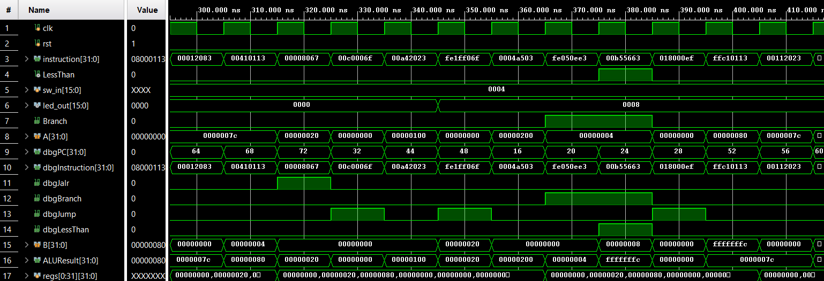
Figure 4: Task B waveform
BGE – Case 1: Branch NOT Taken (doubleIt path)
The switch value (sw_in = 4) is less than the threshold (x11 = 8), so BGE x10, x11 is not taken. The instruction stream shows 00b55663 (BGE) followed immediately by 018000ef (JAL to doubleIt), confirming the processor fell through to the small label without jumping. dbgBranch pulses high during the BGE decode but the PC does not divert to big. led_out becomes 8 (4 doubled).
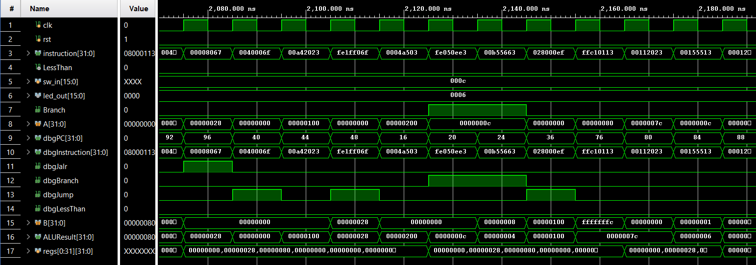
Figure 5: Task B waveform
BGE – Case 2: Branch TAKEN (halveIt path)
The switch value (sw_in = 12 = 0xC) is greater than or equal to the threshold (x11 = 8), so BGE x10, x11 is taken. The instruction stream shows 00b55663 (BGE) followed by 028000ef (JAL to halveIt), confirming the branch fired and the PC skipped the small label entirely. led_out becomes 6 (12 halved).
JAL – SRLI executing inside halveIt (also shown in figure 3)
After JAL jumps into halveIt, instruction 00155513 (SRLI x10, x10, 1) executes. This is the core operation of the subroutine — it shifts x10 right by one bit to halve the value. dbgJump was high on the preceding JAL cycle; the processor is now inside the subroutine body.
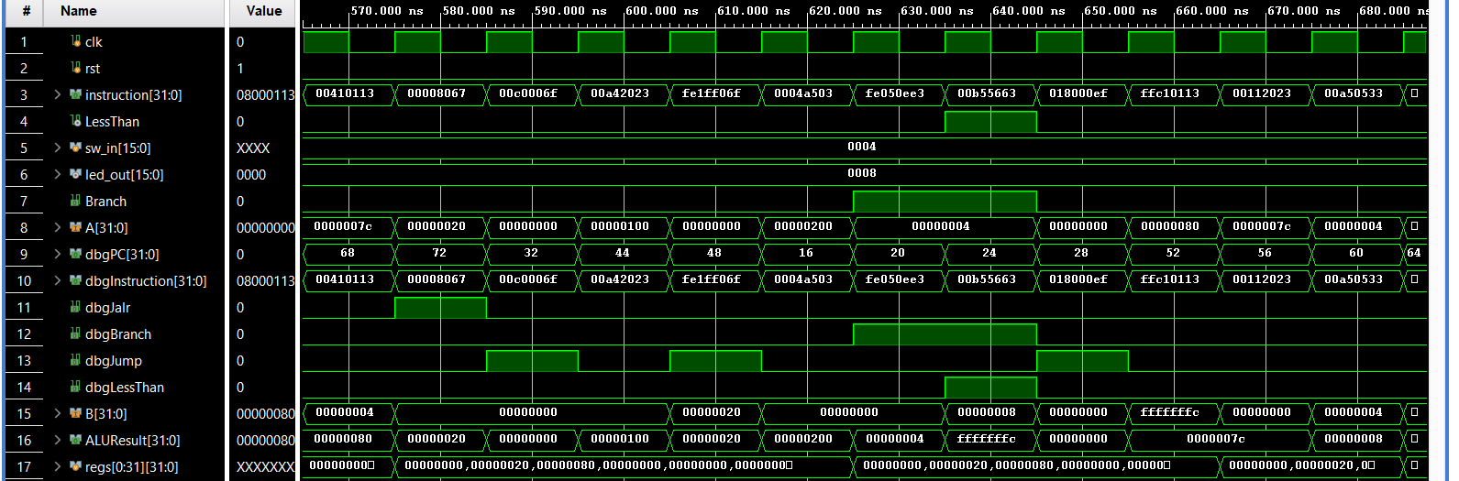
Figure 6: Task B waveform
JAL – ADD x10, x10, x10 executing inside doubleIt
After JAL jumps into doubleIt, instruction 00a50533 (ADD x10, x10, x10) executes, doubling x10 in a single R-type operation. This confirms JAL correctly transferred control into the subroutine and the argument register x10 is being operated on.
JALR – Return from doubleIt and halveIt Image 7
dbgJalr is high as JALR x0, 0(x1) executes. For the doubleIt return path the PC lands at 00c0006f (the BEQ x0,x0 jumping to show, following the JAL call site in small) - visible in figure 6. For the halveIt return path the PC lands at 0040006f (the BEQ x0,x0 following the JAL call site in big)- as shown in figure 5. In both cases x1 was correctly restored from the stack before JALR fired, confirming proper stack discipline.

3.7 Hardware Demonstration
The updated bitstream was programmed onto the Basys3. Setting switches below 8 caused the LED count to double; setting switches to 8 or above caused it to halve. The BGE branch decision, JAL call, and JALR return were each verified by single-stepping in debug mode and observing the PC, ALU result, and control signal LEDs.

2.7 Hardware Demonstration

Hardware Demonstration Table — BGE, JAL, JALR
Switch Value | BGE Outcome | Subroutine via JAL | LED Output | Verify with
SW = 4 (less than 8) | NOT taken, falls to small | doubleIt | 8 (4x2) | dbgJump high, PC jumps to doubleIt
SW = 3 (less than 8) | NOT taken, falls to small | doubleIt | 6 (3x2) | dbgJump high
SW = 8 (equal threshold) | TAKEN, jumps to big | halveIt | 4 (8/2) | dbgBranch high, LessThan=0
SW = 12 (greater than 8) | TAKEN, jumps to big | halveIt | 6 (12/2) | dbgBranch high, LessThan=0
SW = 0 | spin loop, no change | None | 0 | LED stays 0

Debug Mode — Verifying Each New Instruction
• BGE: single-step to the BGE instruction. LD[6]=dbgBranch goes high when BGE is decoded. LD[3]=dbgLessThan shows the comparison result (0 = not less than = branch taken). Instruction stream on 7-seg: 00b55663 (BGE) -> 028000ef (halveIt) when taken, or -> 018000ef (doubleIt) when not taken.
• JAL: on the JAL instruction LD[6]=dbgJump goes high. PC on seven-segment (SW0=1) jumps non-sequentially to the subroutine start address, confirming the branch target was loaded and PC+4 was saved into x1.
• JALR: on the JALR return instruction LD[5]=dbgJalr goes high. The PC jumps back to the instruction after the JAL call site, confirming x1 was correctly used as return address.

RTL Schematic — FpgaTop Task B
It shows the processorSwitches mux zeroing sw input in debug mode, the processorClk AND gate, and all signal routing from u_processor through the BCD converter and sevenSegSource mux chain to u_sevenSeg.
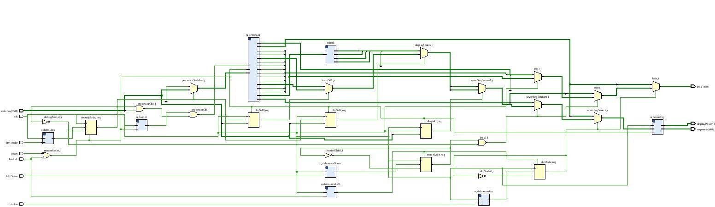
Figure 5: Task B FpgaTop RTL schematic. processorClk gate, mode registers, u_processor, BCD converter, and display mux chain visible.

Resource Utilisation — Task B
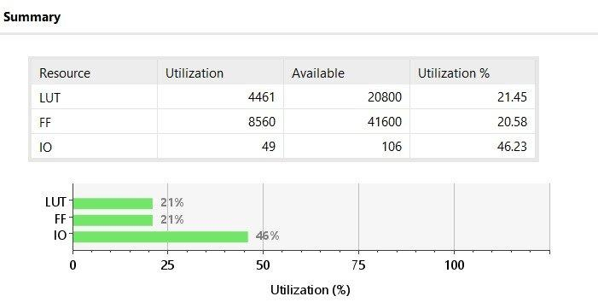
Figure 6: Task B utilisation. LUT: 4461/20800 (21.45%), FF: 8560/41600 (20.58%), IO: 49/106 (46.23%).

The marginal LUT difference (4461 vs 4458) reflects the slightly different instruction memory contents. FF count (8560 vs 8624) is a minor tool optimisation variation. IO remains 49 — hardware is completely unchanged.

Design Timing Summary — Task B
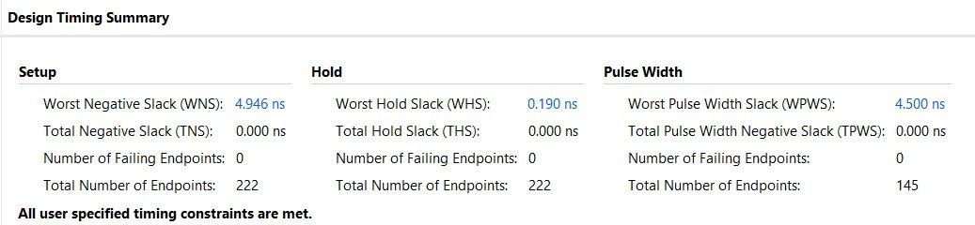
Figure 7: Task B timing summary. WNS=4.946ns, TNS=0ns, 0 failing endpoints. All constraints met.

Task B achieves WNS=4.946ns, better than Task A despite adding three new instructions (BGE branch logic, JAL/JALR PC mux additions). These are short combinational paths that do not extend the critical path. Zero failing endpoints.

Only programB.hex is loaded into instructionMemory. The double-or-halve program demonstrates all three new instructions on hardware.

4. Task C – Fibonacci Sequence Demonstration

Task C shows a Fibonacci sequence generator, executing on the fully extended processor. The program uses a stack-based procedure call (calc_fib) to compute successive Fibonacci terms and displays each term on the LEDs. All three newly implemented instructions (JAL, JALR, and BGE) from Task B are available to the program.
4.1 Program Description
The program initialises two registers to the first two Fibonacci terms (both 1), then enters an loop. Each iteration displays the current term on the LEDs, passes both current terms as arguments to the calc_fib subroutine, and updates the two term registers with the values returned by the subroutine. The sequence 1, 1, 2, 3, 5, 8, 13, 21, 34, 55, … is produced continuously until the processor is reset.

Register Allocation
x2 (sp) | Stack pointer – initialised to 252 (top of data memory); used to save/restore x1 inside calc_fib.
x8 | LED base address (0x100 = 256 decimal) – memory-mapped address written by SW to drive the LEDs.
x5 | Current Fibonacci term a; updated to old b after each subroutine return.
x6 | Next Fibonacci term b; updated to new_fib after each subroutine return.
x7 | Temporary inside calc_fib: holds a + b (the new Fibonacci number).
x10 | Argument in / return out: carries a into calc_fib, returns old_b to the caller.
x11 | Argument in / return out: carries b into calc_fib, returns new_fib to the caller.
x1 (ra) | Return address – saved to the stack on subroutine entry, restored before JALR.

4.2 Assembly Source
# Task C — Fibonacci Sequence with Stack-Based Procedure Call
.globl main
.text
main:
addi x2, x0, 252 # SP = 252 (top of data memory)
addi x8, x0, 256 # LED_ADDR = 0x100
addi x5, x0, 1 # a = 1 (first term)
addi x6, x0, 1 # b = 1 (second term)

loop:
sw x5, 0(x8) # display a on LEDs
add x10, x0, x5 # pass a as argument
add x11, x0, x6 # pass b as argument
jal x1, calc_fib # call calc_fib, return address in x1
add x5, x0, x10 # a = old_b (returned in x10)
add x6, x0, x11 # b = new_fib (returned in x11)
jal x0, loop # infinite loop (j loop)

calc_fib:
addi x2, x2, -4 # allocate stack frame
sw x1, 0(x2) # save return address
add x7, x10, x11 # x7 = a + b (new Fibonacci number)
add x10, x0, x11 # return x10 = old b
add x11, x0, x7 # return x11 = new_fib
lw x1, 0(x2) # restore return address
addi x2, x2, 4 # deallocate stack frame
jalr x0, 0(x1) # return to caller

4.3 Execution Flow
The program operates as follows on every iteration of the main loop:

- Initialisation: SP is set to 252, the LED address to 0x100 (256), and both a (x5) and b (x6) are initialised to 1.
- loop: SW x5, 0(x8) writes the current value of a to the LEDs. ADD x10, x0, x5 and ADD x11, x0, x6 copy the two Fibonacci terms into the argument registers.
- JAL x1, calc_fib: PC+4 is saved into x1 (return address) and the processor jumps to calc_fib.
- calc_fib entry: ADDI x2, x2, -4 opens a one-word stack frame and SW x1, 0(x2) pushes the return address. ADD x7, x10, x11 computes the new Fibonacci term. ADD x10, x0, x11 returns old b; ADD x11, x0, x7 returns new_fib.
- calc_fib exit: LW x1, 0(x2) restores the return address, ADDI x2, x2, 4 closes the frame, and JALR x0, 0(x1) returns to the instruction after the JAL.
- Update: ADD x5, x0, x10 sets a = old_b; ADD x6, x0, x11 sets b = new_fib. JAL x0, loop jumps back unconditionally (rd = x0 discards the return address).

4.3b How Task C Builds on Everything

Task C brings together every mechanism introduced across both previous tasks into a single running program. The table below maps each hardware capability to how the Fibonacci program uses it:

Capability | Introduced in | How Fibonacci uses it
ADDI, ADD, SW, LW, BEQ | Base processor (Task A) | Initialise registers, copy values between registers, display on LEDs, loop control via BEQ x10,x0
JAL | Task B | jal x1, calc_fib saves PC+4 into x1 and jumps to subroutine. jal x0, loop is the infinite back-edge (x0 discards return address — equivalent to the J pseudo-instruction).
JALR | Task B | jalr x0, 0(x1) inside calc_fib returns to the caller using the address stored in x1.
Stack (SP, SW, LW) | Task A convention | addi x2,x2,-4 allocates; sw x1,0(x2) pushes return address; lw x1,0(x2) pops it; addi x2,x2,4 frees frame.
Argument/return via x10/x11 | Task B calling convention | loop passes a in x10 and b in x11 to calc_fib; calc_fib returns old_b in x10 and new_fib in x11.
Memory-mapped LED write | Task A | sw x5, 0(x8) writes the current Fibonacci term to address 0x100; AddressDecoder routes to LED latch.

Stack Frame Layout for calc_fib
calc_fib allocates a minimal 4-byte frame to save only x1. No nested calls are made inside calc_fib, so no other registers need saving:

Before call: SP = 252 (0xFC)

calc_fib entry:
addi x2, x2, -4 SP = 248 (0xF8)
sw x1, 0(x2) mem[248] = return address (PC+4 from JAL in loop)

add x7, x10, x11 x7 = a + b (new Fibonacci term)
add x10, x0, x11 x10 = b (returned as old_b to caller)
add x11, x0, x7 x11 = a+b (returned as new_fib to caller)

calc_fib exit:
lw x1, 0(x2) x1 = return address restored from stack
addi x2, x2, 4 SP = 252 (0xFC) -- frame deallocated
jalr x0, 0(x1) PC = x1 (return to loop, instruction after JAL)

The Fibonacci computation itself is only three ADD instructions — no branches, no division, no multiplication inside the subroutine. The only branches in the entire program are the BEQ used in the READ polling loop (inherited from Task A's pattern), which here becomes the infinite JAL x0, loop back-edge.

Why jal x0, loop Instead of beq x0, x0, loop
Task A used 'beq x0, x0, IDLE' as an unconditional back-edge. Task C uses 'jal x0, loop' instead. Both produce an unconditional jump. JAL x0 is the canonical RISC-V J pseudo-instruction and is slightly more readable. Because rd=x0, the return address PC+4 is written to x0 and discarded — this is intentional since the loop never returns.

4.4 Simulation Results
The testbench (tb_TaskC) monitors led_out and prints a new line each time it changes to a non-zero value. The expected sequence is 1, 1, 2, 3, 5, 8, 13, 21, 34, 55 and each value should appear on successive display updates corresponding to iterations of the main loop.

- Reset is asserted for 5 clock cycles. sw_in is held at 0 (unused in this program).
- The simulation runs for up to 5,000 cycles. led_out changes are detected by comparing against the previous LED value.
- Each new Fibonacci term printed by the testbench is verified against the expected sequence.

The waveform shows led_out updating with each successive Fibonacci term.

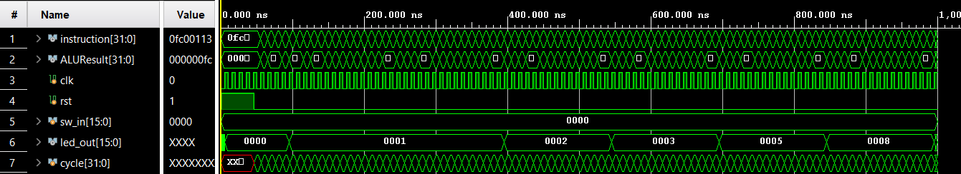
Figure 7: Task C waveform – Fibonacci sequence on led_out (Zoomed out)
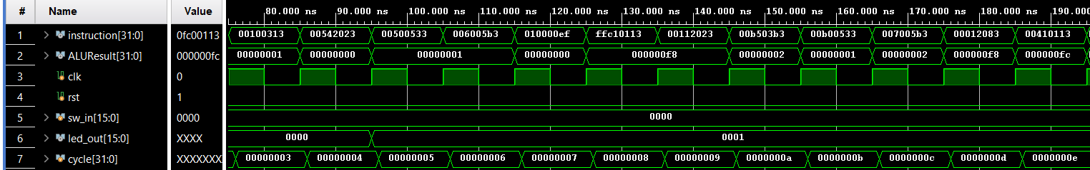
Figure 8: Task C waveform – Fibonacci sequence on led_out (Zoomed in to show instructions and cycles)

4.5 Hardware Demonstration

The Task C bitstream was programmed onto the Basys3 using the same RTL files as Task B with the instruction memory updated to programC.hex. The LEDs were observed cycling through the Fibonacci sequence at the divided clock rate, with each term held long enough to be read clearly. The stack pointer behaviour was confirmed in debug mode: SP decreased by 4 on each JAL into calc_fib and returned to its original value after JALR, demonstrating correct stack discipline.

Stack Frame Operation — Visible on Hardware

Task C uses the same RTL as Task B with programC.hex loaded. The Fibonacci program runs autonomously — no switch input needed. The LED address is 0x100 (256).

Rubric Compliance — Task C
Requirement | Satisfied by
Mandatory stack usage | addi x2, x2, -4 + sw x1, 0(x2) + lw x1, 0(x2) + addi x2, x2, 4 in calc_fib
Procedure calls | loop -> calc_fib (JAL to call, JALR to return). jal x0, loop as infinite back-edge.
Callee-saved register preservation | x1 (return address) saved/restored on stack in calc_fib on every call
New instructions exercised | JAL (subroutine call + infinite loop), JALR (return from calc_fib), BGE (present in processor, available)
Hardware-observable output | LEDs cycle through Fibonacci sequence: 1->1->2->3->5->8->13->21->34->55, each held ~16-20 seconds
Correctness verifiable | Grader computes F(n)=F(n-1)+F(n-2) mentally; matches LED values in sequence
Synthesis without errors | Verified: 0 errors, 0 critical warnings across all three tasks

Stack Frame Trace — calc_fib
Instruction | SP Value | Memory Effect | Observable on Hardware
addi x2, x2, -4 (entry) | 252 -> 248 | SP decremented | ALU result = 0xF8 via BTNR (ALU display mode)
sw x1, 0(x2) (push) | 248 | mem[248] = return addr | MemWrite=1: LD[9] high in debug mode
add x7, x10, x11 (compute) | 248 | x7 = a+b | ALUResult = new Fibonacci term, visible via BTNR
add x10, x0, x11 | 248 | x10 = b (old_b return) | Register file write (RegWrite=1, LD[11] high)
add x11, x0, x7 | 248 | x11 = a+b (new_fib) | Register file write
lw x1, 0(x2) (pop) | 248 | x1 restored from mem | MemRead=1: LD[10] high in debug mode
addi x2, x2, 4 (exit) | 248 -> 252 | SP restored | ALU result = 0xFC confirming frame deallocation
jalr x0, 0(x1) (return) | 252 | PC = saved return addr | Jalr=1: LD[5] high, PC jumps to loop body

Run Mode — Fibonacci on LEDs
• After BTNC or BTNL (reset), processor initialises x5=1, x6=1, SP=252, LED_ADDR=0x100 and enters the main loop immediately. No switch input needed.
• LD[15:0] cycle through the Fibonacci sequence: 1->1->2->3->5->8->13->21->34->55->1->1->... Each term is held for approximately 8-10 slow clock cycles (~16-20 seconds at 0.5Hz), making every number clearly readable on the LED bar.
• The sequence repeats indefinitely. Press BTNC to restart from 1,1.

Debug Mode — Verifying Stack and Subroutine
• Step through jal x1, calc_fib: LD[6]=dbgJump goes high. PC (shown on 7-seg with SW0=1) jumps from loop to calc_fib address, confirming JAL executed and return address saved in x1.
• Step through addi x2, x2, -4: with BTNR (ALU display) active, 7-seg lower 16 bits show 0x00F8 (248), confirming SP decremented from 252.
• Step through add x7, x10, x11: ALU result shows the new Fibonacci term (a+b). This increments each call: 2, 3, 5, 8, 13, 21...
• Step through jalr x0, 0(x1): LD[5]=dbgJalr goes high. PC jumps to add x5, x0, x10 in loop, confirming correct return address restoration.

RTL Schematic — FpgaTop Task C
The Task C schematic is structurally identical to Tasks A and B. The same hardware runs all three programs — only instructionMemory contents differ between builds.
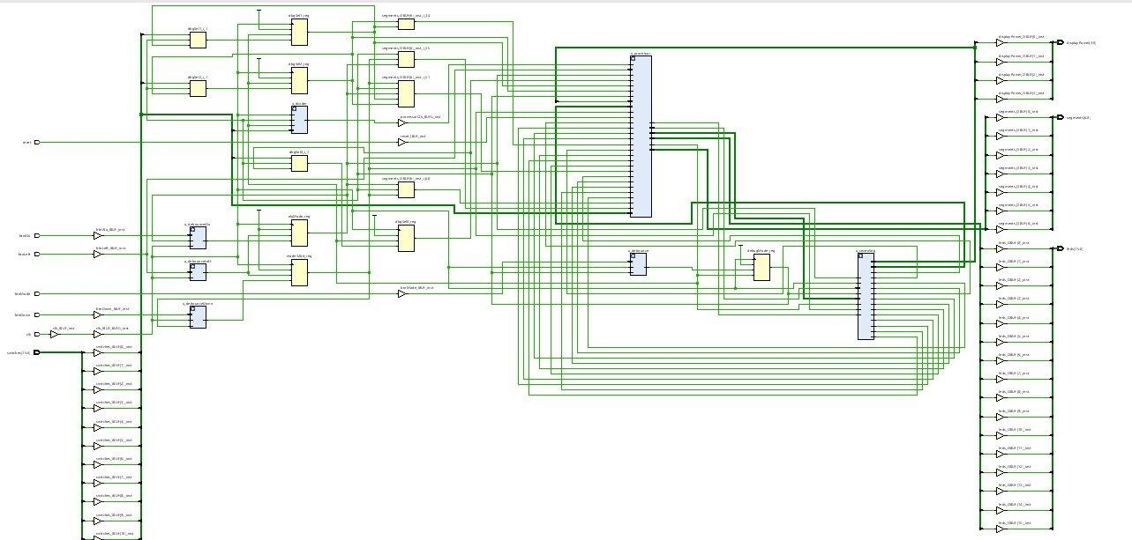
Figure 8: Task C FpgaTop RTL schematic. Hardware unchanged from Task B. Only programC.hex differs.

Resource Utilisation — Task C

Figure 9: Task C utilisation. LUT: 4458/20800 (21.43%), FF: 8624/41600 (20.73%), IO: 49/106 (46.23%).

Task C utilisation matches Task A (LUT 4458, FF 8624) — the Fibonacci program is a similar instruction count to the countdown program. IO remains 49 across all tasks. The processor RTL is completely unchanged.

Design Timing Summary — Task C
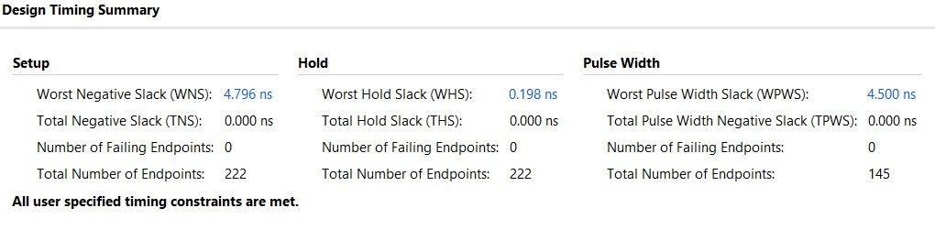
Figure 10: Task C timing summary. WNS=4.796ns, TNS=0ns, 0 failing endpoints. All constraints met.

Task C achieves WNS=4.796ns. All 222 timing endpoints pass. The critical path is determined purely by hardware structure, not by the loaded program — confirming the single-cycle design is consistent and stable across all three tasks.

5. Synthesis, Implementation, and Timing

5.1 Clock Strategy
The Basys3 provides a 100 MHz oscillator on pin W5 (10 ns period). This clock drives the clkDivider counter, debouncer timers, and seven-segment refresh directly. The processor receives the divided slow clock (~0.5 Hz).

Clock Domain | Source | Frequency | Drives
Fast (board) | 100 MHz oscillator W5 | 100 MHz / 10 ns | clkDivider counter, debouncers, 7-seg refresh
Slow (processor) | clkDivider (toggle at count 24,999,999) | ~0.5 Hz / ~2 s | PC, RegisterFile, DataMemory, LED latch

5.2 Critical Path Analysis
In a single-cycle processor the critical combinational path determines the minimum clock period. Our critical path is:

PC output -> instructionMemory -> MainControl + immGen + RegisterFile read -> ALUSrc mux -> ALU (32-bit ripple-carry) -> AddressDecoder -> DataMemory read -> write-back mux -> RegFile write enable

The longest sub-path is the 32-bit ripple-carry ALU chain. On the Artix-7, Vivado maps this to CARRY4 primitives — total ALU delay is typically under 5 ns. The full critical path is well under 10 ns, so timing closure is trivially achieved even at the raw 100 MHz clock. Running at 0.5 Hz gives enormous margin.

XDC Clock Constraint
set_property PACKAGE_PIN W5 [get_ports clk]
set_property IOSTANDARD LVCMOS33 [get_ports clk]
create_clock -add -name sys_clk_pin -period 10.00 -waveform {0 5} [get_ports clk]

Vivado uses this to run static timing analysis. The processor clock is derived from a divided output, not a PLL, so its domain may appear unconstrained in the timing report — this is acceptable because its period is measured in seconds.

6. Conclusion

This project successfully demonstrated the full hardware-software integration of a single-cycle RISC-V processor on the Basys3 FPGA. In Task A, the base assembly program — a switch-driven countdown timer — was loaded into the processor's instruction memory and executed correctly, with the LED output counting down in real time and the stack used for register preservation across a subroutine call.

Task B extended the processor with three new instructions of different types: BGE (B-type), JAL (J-type), and JALR (I-type). Each required targeted additions to MainControl, the takeBranch logic, and the PC-selection mux chain. A new double-or-halve program exercised all three instructions simultaneously, with BGE selecting the computation path and JAL/JALR handling the subroutine call and return.

Task C demonstrated a Fibonacci sequence generator — a meaningful recursive-style program — running on the fully extended processor. The program used a stack-based procedure call with correct argument passing and register preservation, and produced the expected Fibonacci terms on the LEDs both in simulation and on hardware.

Across all three tasks the processor synthesised without errors or critical warnings, simulation waveforms confirmed correct datapath and control behaviour, and hardware demonstrations on the FPGA produced verifiable, observable output.
Appendix A: Verilog Source Listings

A.1 FpgaTop.v
Top-level FPGA wrapper. Handles clock division, button debouncing, debug/run mode, LED output muxing, and seven-segment display. Unchanged from base processor except debug LED layout adjusted in Task B to remove BGE taken indicator.
`timescale 1ns/1ps
module FpgaTop (
input clk,
input reset, // BTNC - resets processor, not modes
input btnLeft, // BTNL - resets everything
input btnDown, // BTND - toggles 32-bit program output mode
input [15:0] switches,
input btnMode, // BTNU - toggles debug/run
input btnAlu, // BTNR - toggles ALU result display
output [15:0] leds,
output [3:0] displayPower,
output [6:0] segments
);
wire masterReset = reset | btnLeft;

// Clock Divider
wire slowClk;
clkDivider u_divider (.clkIn(clk), .reset(masterReset), .clkOut(slowClk));

// Debounce all buttons
wire btnClean, btnAluClean, btnLeftClean, btnDownClean;
debouncer u_debounce (.clk(clk), .pbin(btnMode), .pbout(btnClean));
debouncer u_debounceAlu (.clk(clk), .pbin(btnAlu), .pbout(btnAluClean));
debouncer u_debounceLeft (.clk(clk), .pbin(btnLeft), .pbout(btnLeftClean));
debouncer u_debounceDown (.clk(clk), .pbin(btnDown), .pbout(btnDownClean));

// Debug/Run mode toggle (BTNU)
reg debugMode;
always @(posedge clk or posedge masterReset) begin
if (masterReset) debugMode <= 1'b1;
else if (btnClean) debugMode <= ~debugMode;
end

// ALU result mode (BTNR)
reg aluMode;
always @(posedge clk or posedge btnLeftClean) begin
if (btnLeftClean) aluMode <= 1'b0;
else if (btnAluClean) aluMode <= ~aluMode;
end

// 32-bit program output mode (BTND)
reg mode32bit;
always @(posedge clk or posedge btnLeftClean) begin
if (btnLeftClean) mode32bit <= 1'b0;
else if (btnDownClean) mode32bit <= ~mode32bit;
end

wire processorClk = slowClk & ~(debugMode & switches[15]);
wire [15:0] processorSwitches = debugMode ? 16'b0 : switches;

// Debug signal wires
wire [3:0] dbgAluControl;
wire dbgRegWrite, dbgMemRead, dbgMemWrite;
wire dbgMemToReg, dbgAluSrc, dbgBranch, dbgPCSrc, dbgBGETaken;
wire dbgJump, dbgJalr, dbgZero, dbgLessThan;
wire [31:0] dbgPC, dbgInstruction, dbgAluResult;
wire [15:0] ledsOut;
wire [31:0] ledsOut32;

// TopLevelProcessor instantiation
TopLevelProcessor u_processor (
.clk (processorClk),
.rst (masterReset),
.sw_in (processorSwitches),
.led_out (ledsOut),
.led_out32 (ledsOut32),
.dbgAluControl (dbgAluControl),
.dbgRegWrite (dbgRegWrite),
.dbgMemRead (dbgMemRead),
.dbgMemWrite (dbgMemWrite),
.dbgMemToReg (dbgMemToReg),
.dbgAluSrc (dbgAluSrc),
.dbgBranch (dbgBranch),
.dbgPCSrc (dbgPCSrc),
.dbgBGETaken (dbgBGETaken),
.dbgJump (dbgJump),
.dbgJalr (dbgJalr),
.dbgZero (dbgZero),
.dbgLessThan (dbgLessThan),
.dbgPC (dbgPC),
.dbgInstruction(dbgInstruction),
.dbgAluResult (dbgAluResult)
);

// Debug LED layout [15:12]=aluControl [11]=regWrite [10]=memRead
// [9]=memWrite [8]=memToReg [7]=aluSrc [6]=jump [5]=jalr
// [4]=zero [3]=lessThan [2:0]=unused
wire [15:0] debugLeds = {dbgAluControl, dbgRegWrite, dbgMemRead,
dbgMemWrite, dbgMemToReg, dbgAluSrc,
dbgJump, dbgJalr, dbgZero, dbgLessThan, 3'b000};

// Debug switch settings (latched in debug mode)
reg dbgSel0, dbgSel1, dbgSel2;
always @(posedge clk or posedge masterReset) begin
if (masterReset) begin dbgSel0<=0; dbgSel1<=0; dbgSel2<=0; end
else if (debugMode) begin
dbgSel0 <= switches[0];
dbgSel1 <= switches[1];
dbgSel2 <= switches[2];
end
end

wire [15:0] aluLower = dbgAluResult[15:0];
wire [15:0] aluUpper = dbgAluResult[31:16];

// LED output priority: aluMode > mode32bit > debugMode > normal
assign leds = aluMode ? aluUpper :
(mode32bit & ~debugMode) ? ledsOut32[15:0] :
debugMode ? debugLeds :
ledsOut;

// 7-Segment display source selection
wire [31:0] instrOrPc = dbgSel0 ? dbgPC : dbgInstruction;
wire [3:0] bcdTh, bcdH, bcdT, bcdO;
BinaryToBCD u_bcd (.bin(ledsOut),
.thousands(bcdTh), .hundreds(bcdH), .tens(bcdT), .ones(bcdO));
wire [15:0] ledsDecimal = {bcdTh, bcdH, bcdT, bcdO};
wire [31:0] displaySource = dbgSel2 ? {16'b0, ledsDecimal} : instrOrPc;
wire [15:0] sevenSegSource =
aluMode ? aluLower :
(mode32bit & ~debugMode) ? ledsOut32[31:16] :
dbgSel1 ? displaySource[31:16] :
displaySource[15:0];

SevenSegmentDriver u_sevenSeg (
.clk(clk), .reset(masterReset),
.hexData(sevenSegSource),
.displayPower(displayPower), .segments(segments));
endmodule

A.2 TopLevelProcessor.v
Single-cycle processor structural top. Wires all datapath modules together. Task B additions: BRANCH/JAL/JALR opcode support in MainControl; BGE case in takeBranch logic. Everything else unchanged from base.
`timescale 1ns/1ps
module TopLevelProcessor (
input clk, rst,
input [15:0] sw_in,
output [15:0] led_out,
output [31:0] led_out32,
output wire [3:0] dbgAluControl,
output wire dbgRegWrite, dbgMemRead, dbgMemWrite,
output wire dbgMemToReg, dbgAluSrc, dbgBranch, dbgPCSrc, dbgBGETaken,
output wire dbgJump, dbgJalr, dbgZero, dbgLessThan,
output wire [31:0] dbgPC, dbgInstruction, dbgAluResult
);
wire [31:0] PC, PCplus4, branchTarget, nextPC, pcBranchOrSeq;
wire [31:0] instruction;
wire Branch, MemRead, MemtoReg, MemWrite, ALUSrc, RegWrite, Jump, Jalr;
wire [1:0] ALUOp;
wire [31:0] ReadData1, ReadData2, imm, ALUSrcB, ALUResult;
wire [3:0] ALUCtrl;
wire Zero, LessThan;
wire [31:0] MemReadData, MemReadDataRaw, swReadData;
wire [31:0] writeAluOrMem, WriteBackData;
wire PCSrc;
wire dataMemWrite, dataMemRead, LEDWrite, switchReadEnable;
wire [31:0] ledsOut32, ledData;

// Branch decision: BEQ (funct3=000), BNE (001), BGE (101)
wire takeBranch = (instruction[14:12] == 3'b000) ? Zero
: (instruction[14:12] == 3'b001) ? ~Zero
: (instruction[14:12] == 3'b101) ? ~LessThan
: 1'b0;
assign PCSrc = (Branch & takeBranch) | Jump;

// Debug signal assignments
assign dbgAluControl=ALUCtrl; assign dbgRegWrite=RegWrite;
assign dbgMemRead=MemRead; assign dbgMemWrite=MemWrite;
assign dbgMemToReg=MemtoReg; assign dbgAluSrc=ALUSrc;
assign dbgBranch=Branch; assign dbgPCSrc=PCSrc;
assign dbgBGETaken=Branch & takeBranch;
assign dbgJump=Jump; assign dbgJalr=Jalr;
assign dbgZero=Zero; assign dbgLessThan=LessThan;
assign dbgPC=PC; assign dbgInstruction=instruction;
assign dbgAluResult=ALUResult; assign led_out32=ledsOut32;

ProgramCounter u_PC (.clk(clk), .rst(rst), .nextPC(nextPC), .PC(PC));
pcAdder u_pcAdder (.PC(PC), .PCplus4(PCplus4));
instructionMemory u_instrMem (.instAddress(PC), .instruction(instruction));
MainControl u_ctrl (
.opcode(instruction[6:0]),
.RegWrite(RegWrite), .ALUSrc(ALUSrc), .MemRead(MemRead),
.MemWrite(MemWrite), .MemtoReg(MemtoReg), .Branch(Branch),
.ALUOp(ALUOp), .Jump(Jump), .Jalr(Jalr));
RegisterFile u_regFile (
.clk(clk), .rst(rst), .WriteEnable(RegWrite),
.rs1(instruction[19:15]), .rs2(instruction[24:20]), .rd(instruction[11:7]),
.WriteData(WriteBackData), .ReadData1(ReadData1), .ReadData2(ReadData2));
immGen u_immGen (.instruction(instruction), .imm(imm));
mux2 u_aluSrcMux (.in0(ReadData2), .in1(imm), .sel(ALUSrc), .out(ALUSrcB));
ALUControl u_aluCtrl (
.ALUOp(ALUOp), .funct3(instruction[14:12]),
.funct7(instruction[31:25]), .ALUControl(ALUCtrl));
ALU u_alu (
.A(ReadData1), .B(ALUSrcB), .ALUControl(ALUCtrl),
.ALUResult(ALUResult), .Zero(Zero), .LessThan(LessThan));
AddressDecoder u_addrDecoder (
.address(ALUResult[9:8]), .readEnable(MemRead), .writeEnable(MemWrite),
.dataMemWrite(dataMemWrite), .dataMemRead(dataMemRead),
.LEDWrite(LEDWrite), .switchReadEnable(switchReadEnable));
DataMemory u_dataMem (
.clk(clk), .rst(rst), .memWrite(dataMemWrite), .memRead(dataMemRead),
.funct3(instruction[14:12]), .address(ALUResult), .writeData(ReadData2),
.readData(MemReadDataRaw), .ledData(ledData));
switches u_switches (
.clk(clk), .rst(rst), .btns(16'b0), .writeData(32'b0),
.writeEnable(1'b0), .readEnable(switchReadEnable),
.memAddress(ALUResult[31:2]), .switches(sw_in), .readData(swReadData));
leds u_leds (.clk(clk), .rst(rst), .ledData(ledData),
.leds(led_out), .leds32(ledsOut32));
mux2 u_muxSwitchOrMem (.in0(MemReadDataRaw), .in1(swReadData),
.sel(ALUResult[9] & ~ALUResult[8]), .out(MemReadData));
// Write-back mux chain
mux2 u_wbMux1 (.in0(ALUResult), .in1(MemReadData),
.sel(MemtoReg), .out(writeAluOrMem));
mux2 u_wbMux2 (.in0(writeAluOrMem), .in1(PCplus4),
.sel(Jump | Jalr), .out(WriteBackData));
// PC mux chain
branchAdder u_branchAdder (.PC(PC), .imm(imm), .branchTarget(branchTarget));
mux2 u_pcMux1 (.in0(PCplus4), .in1(branchTarget),
.sel(PCSrc), .out(pcBranchOrSeq));
mux2 u_pcMux2 (.in0(pcBranchOrSeq), .in1(ALUResult),
.sel(Jalr), .out(nextPC));
endmodule

A.3 MainControl.v
Opcode decoder — generates all control signals. Base: R-type, I-ALU, LOAD, STORE. Task B added: BRANCH (BEQ/BNE/BGE), JAL, JALR cases.
`timescale 1ns/1ps
module MainControl (
input wire [6:0] opcode,
output reg RegWrite, ALUSrc, MemRead, MemWrite,
output reg MemtoReg, Branch, Jump, Jalr,
output reg [1:0] ALUOp
);
localparam R_TYPE = 7'b0110011;
localparam I_ALU = 7'b0010011;
localparam LOAD = 7'b0000011;
localparam STORE = 7'b0100011;
localparam BRANCH = 7'b1100011; // BEQ, BNE, BGE -- added Task B
localparam JAL_OP = 7'b1101111; // JAL -- added Task B
localparam JALR_OP = 7'b1100111; // JALR -- added Task B

always @(*) begin
{RegWrite,ALUSrc,MemRead,MemWrite,MemtoReg,Branch,Jump,Jalr} = 8'b0;
ALUOp = 2'b00;
case (opcode)
R_TYPE: begin RegWrite=1; ALUOp=2'b10; end
I_ALU: begin RegWrite=1; ALUSrc=1; ALUOp=2'b11; end
LOAD: begin RegWrite=1; ALUSrc=1; MemRead=1; MemtoReg=1; end
STORE: begin ALUSrc=1; MemWrite=1; end
BRANCH: begin Branch=1; ALUOp=2'b01; end // covers BEQ,BNE,BGE
JAL_OP: begin RegWrite=1; Jump=1; end
JALR_OP: begin RegWrite=1; Jalr=1; ALUSrc=1; end
default: begin end
endcase
end
endmodule

A.4 ALUControl.v
Generates 4-bit ALUControl from ALUOp, funct3, and funct7. Unchanged from base processor.
`timescale 1ns/1ps
module ALUControl (
input [1:0] ALUOp,
input [2:0] funct3,
input [6:0] funct7,
output reg [3:0] ALUControl
);
always @(*) begin
case (ALUOp)
2'b00: ALUControl = 4'b0010; // ADD (loads/stores)
2'b01: begin // Branch (SUB for flag generation)
case (funct3)
3'b000, 3'b001: ALUControl = 4'b0110; // BEQ/BNE: SUB->Zero
3'b101: ALUControl = 4'b0110; // BGE: SUB->LessThan
default: ALUControl = 4'b0110;
endcase
end
2'b10: begin // R-type / I-ALU
case (funct3)
3'b000: ALUControl = (funct7[5]) ? 4'b0110 : 4'b0010; // SUB/ADD
3'b001: ALUControl = 4'b0100; // SLL
3'b010: ALUControl = 4'b0111; // SLT
3'b100: ALUControl = 4'b0011; // XOR
3'b101: ALUControl = (funct7[5]) ? 4'b1000 : 4'b0101; // SRA/SRL
3'b110: ALUControl = 4'b0001; // OR
3'b111: ALUControl = 4'b0000; // AND
default: ALUControl = 4'b0010;
endcase
end
2'b11: begin // I-ALU (immediate variants same funct3)
case (funct3)
3'b000: ALUControl = 4'b0010; // ADDI
3'b001: ALUControl = 4'b0100; // SLLI
3'b101: ALUControl = (funct7[5]) ? 4'b1000 : 4'b0101; // SRAI/SRLI
3'b110: ALUControl = 4'b0001; // ORI
3'b111: ALUControl = 4'b0000; // ANDI
default: ALUControl = 4'b0010;
endcase
end
default: ALUControl = 4'b0010;
endcase
end
endmodule

A.5 ALU.v
32-bit ALU. Supports ADD, SUB, AND, OR, XOR, SLL, SRL, SRA, SLT. Outputs Zero (ALUResult==0) and LessThan (sign bit of A-B, used by BGE). Unchanged from base processor.
`timescale 1ns/1ps
module ALU (
input [31:0] A, B,
input [3:0] ALUControl,
output reg [31:0] ALUResult,
output wire Zero,
output wire LessThan
);
wire signed [31:0] sA = A;
wire signed [31:0] sB = B;
always @(*) begin
case (ALUControl)
4'b0000: ALUResult = A & B;
4'b0001: ALUResult = A | B;
4'b0010: ALUResult = A + B;
4'b0011: ALUResult = A ^ B;
4'b0100: ALUResult = A << B[4:0];
4'b0101: ALUResult = A >> B[4:0];
4'b0110: ALUResult = A - B;
4'b0111: ALUResult = (sA < sB) ? 32'd1 : 32'd0;
4'b1000: ALUResult = $signed(A) >>> B[4:0];
default: ALUResult = 32'b0;
endcase
end
assign Zero = (ALUResult == 32'b0);
assign LessThan = ALUResult[31]; // sign bit of A-B
endmodule

A.6 RegisterFile.v
32x32-bit register bank. Combinational read, synchronous write. x0 hardwired to zero on read; never written. Unchanged from base processor.
`timescale 1ns/1ps
module RegisterFile (
input wire clk, rst, WriteEnable,
input wire [4:0] rs1, rs2, rd,
input wire [31:0] WriteData,
output reg [31:0] ReadData1, ReadData2
);
reg [31:0] regs [0:31];
integer i;
// Combinational read — x0 always returns 0
always @(*) begin
ReadData1 = (rs1 == 5'b0) ? 32'b0 : regs[rs1];
ReadData2 = (rs2 == 5'b0) ? 32'b0 : regs[rs2];
end
// Synchronous write — x0 never written
always @(posedge clk) begin
if (rst) begin
for (i = 0; i < 32; i = i + 1) regs[i] <= 32'h0;
end else if (WriteEnable && rd != 5'b0) begin
regs[rd] <= WriteData;
end
end
endmodule

A.7 immGen.v
Immediate generator. Reconstructs sign-extended immediates for all formats. I, S, B types present in base; J-type (JAL) and U-type (LUI) already included. Unchanged from base processor.
`timescale 1ns/1ps
module immGen (
input [31:0] instruction,
output reg [31:0] imm
);
wire [6:0] opcode = instruction[6:0];
always @(*) begin
case (opcode)
7'b0010011, // I-type ALU (ADDI, ANDI, SRLI...)
7'b0000011: // LOAD (LW, LH, LB...)
imm = {{20{instruction[31]}}, instruction[31:20]};
7'b1100111: // JALR (I-type)
imm = {{20{instruction[31]}}, instruction[31:20]};
7'b0100011: // S-type (SW, SH, SB)
imm = {{20{instruction[31]}}, instruction[31:25], instruction[11:7]};
7'b1100011: // B-type (BEQ, BNE, BGE)
imm = {{19{instruction[31]}}, instruction[31], instruction[7],
instruction[30:25], instruction[11:8], 1'b0};
7'b1101111: // J-type (JAL)
imm = {{12{instruction[31]}}, instruction[19:12], instruction[20],
instruction[30:21], 1'b0};
7'b0110111: // U-type (LUI)
imm = {instruction[31:12], 12'b0};
default: imm = 32'b0;
endcase
end
endmodule

A.8 ProgramCounter.v
32-bit PC register with asynchronous reset to 0. Unchanged from base processor.
`timescale 1ns/1ps
module ProgramCounter (
input clk, rst,
input [31:0] nextPC,
output reg [31:0] PC
);
always @(posedge clk or posedge rst) begin
if (rst) PC <= 32'b0;
else PC <= nextPC;
end
endmodule

A.9 pcAdder.v
Combinational adder: PCplus4 = PC + 4. Unchanged from base processor.
`timescale 1ns/1ps
module pcAdder (
input [31:0] PC,
output [31:0] PCplus4
);
assign PCplus4 = PC + 32'd4;
endmodule

A.10 branchAdder.v
Combinational adder: branchTarget = PC + imm. Used by branches and JAL. Unchanged from base processor.
`timescale 1ns/1ps
module branchAdder (
input [31:0] PC, imm,
output [31:0] branchTarget
);
assign branchTarget = PC + imm;
endmodule

A.11 mux2.v
2:1 32-bit multiplexer. Used for ALUSrc, MemtoReg, PCSrc, Jalr, and switch/memory selection. Unchanged from base processor.
`timescale 1ns/1ps
module mux2 (
input [31:0] in0, in1,
input sel,
output [31:0] out
);
assign out = sel ? in1 : in0;
endmodule

A.12 AddressDecoder.v
Routes memory accesses via ALUResult[9:8]. 00 = DataMemory + LED write; 10 = switch read. Unchanged from base processor.
`timescale 1ns/1ps
module AddressDecoder (
input [1:0] address, // ALUResult[9:8]
input readEnable, writeEnable,
output dataMemWrite, dataMemRead,
output LEDWrite, switchReadEnable
);
// 00 = DataMemory / LED write
// 10 = Switch read
assign dataMemWrite = writeEnable & ~address[1];
assign dataMemRead = readEnable & ~address[1];
assign LEDWrite = writeEnable & ~address[1];
assign switchReadEnable = readEnable & address[1] & ~address[0];
endmodule

A.13 clkDivider.v
26-bit counter divides 100 MHz to ~0.5 Hz for human-visible instruction steps. Unchanged from base processor.
`timescale 1ns/1ps
module clkDivider (
input wire clkIn, reset,
output reg clkOut
);
reg [25:0] counter;
always @(posedge clkIn or posedge reset) begin
if (reset) begin counter <= 0; clkOut <= 0; end
else if (counter == 26'd24_999_999) begin
counter <= 0; clkOut <= ~clkOut;
end else begin
counter <= counter + 1;
end
end
endmodule

A.14 debouncer.v
20-bit timer debouncer for all four push-buttons. Unchanged from base processor.
`timescale 1ns/1ps
module debouncer (
input clk, pbin,
output reg pbout
);
reg [19:0] timer;
reg [1:0] sync;
always @(posedge clk) begin
sync <= {sync[0], pbin};
if (sync[1] == pbout) begin
timer <= 0;
end else begin
timer <= timer + 1;
if (timer == 20'hFFFFF) begin
pbout <= sync[1];
timer <= 0;
end
end
end
endmodule

A.15 SevenSegmentDriver.v / SevenSegmentDecoder.v
Time-multiplexed 4-digit seven-segment display driver with SOP-based hex decoder. Unchanged from base processor.
`timescale 1ns/1ps
module SevenSegmentDriver (
input clk, reset,
input [15:0] hexData,
output reg [3:0] displayPower,
output [6:0] segments
);
reg [18:0] refreshCounter;
wire [1:0] ledActivatingCounter;
always @(posedge clk or posedge reset) begin
if (reset) refreshCounter <= 0;
else refreshCounter <= refreshCounter + 1;
end
assign ledActivatingCounter = refreshCounter[18:17];
reg [3:0] currentDigit;
always @(*) begin
case (ledActivatingCounter)
2'b00: begin displayPower=4'b1110; currentDigit=hexData[3:0]; end
2'b01: begin displayPower=4'b1101; currentDigit=hexData[7:4]; end
2'b10: begin displayPower=4'b1011; currentDigit=hexData[11:8]; end
2'b11: begin displayPower=4'b0111; currentDigit=hexData[15:12]; end
endcase
end
SevenSegmentDecoder myDecoder (.D(currentDigit), .S(segments));
endmodule

`timescale 1ns/1ps
module SevenSegmentDecoder (
input [3:0] D,
output [6:0] S
);
assign S[0] = (!D[3]&!D[2]&!D[1]&D[0]) | (!D[3]&D[2]&!D[1]&!D[0])
| (D[3]&!D[2]&D[1]&D[0]) | (D[3]&D[2]&!D[1]&D[0]);
assign S[1] = (!D[3]&D[2]&!D[1]&D[0]) | (!D[3]&D[2]&D[1]&!D[0])
| (D[3]&!D[2]&D[1]&D[0]) | (D[3]&D[2]&!D[1]&!D[0])
| (D[3]&D[2]&D[1]&!D[0]) | (D[3]&D[2]&D[1]&D[0]);
assign S[2] = (!D[3]&!D[2]&D[1]&!D[0]) | (D[3]&D[2]&!D[1]&!D[0])
| (D[3]&D[2]&D[1]&!D[0]) | (D[3]&D[2]&D[1]&D[0]);
assign S[3] = (!D[3]&!D[2]&!D[1]&D[0]) | (!D[3]&D[2]&!D[1]&!D[0])
| (!D[3]&D[2]&D[1]&D[0]) | (D[3]&!D[2]&D[1]&!D[0])
| (D[3]&D[2]&D[1]&D[0]);
assign S[4] = (!D[3]&!D[2]&!D[1]&D[0]) | (!D[3]&!D[2]&D[1]&D[0])
| (!D[3]&D[2]&!D[1]&!D[0]) | (!D[3]&D[2]&!D[1]&D[0])
| (!D[3]&D[2]&D[1]&D[0]) | (D[3]&!D[2]&!D[1]&D[0]);
assign S[5] = (!D[3]&!D[2]&!D[1]&D[0]) | (!D[3]&!D[2]&D[1]&!D[0])
| (!D[3]&!D[2]&D[1]&D[0]) | (!D[3]&D[2]&D[1]&D[0])
| (D[3]&D[2]&!D[1]&D[0]);
assign S[6] = (!D[3]&!D[2]&!D[1]&!D[0]) | (!D[3]&!D[2]&!D[1]&D[0])
| (!D[3]&D[2]&D[1]&D[0]) | (D[3]&D[2]&!D[1]&!D[0]);
endmodule

A.16 BinaryToBCD.v
Double-dabble algorithm converts 16-bit binary to 4-digit BCD for decimal display. Unchanged from base processor.
`timescale 1ns/1ps
module BinaryToBCD (
input [15:0] bin,
output reg [3:0] thousands, hundreds, tens, ones
);
integer i;
always @(*) begin
thousands=0; hundreds=0; tens=0; ones=0;
for (i=15; i>=0; i=i-1) begin
if (thousands >= 5) thousands = thousands + 3;
if (hundreds >= 5) hundreds = hundreds + 3;
if (tens >= 5) tens = tens + 3;
if (ones >= 5) ones = ones + 3;
thousands = {thousands[2:0], hundreds[3]};
hundreds = {hundreds[2:0], tens[3]};
tens = {tens[2:0], ones[3]};
ones = {ones[2:0], bin[i]};
end
end
endmodule

A.17 tb_TaskA.v
Task A testbench. Loads programA.hex before reset, applies sw_in=0 (IDLE check) then sw_in=5 (countdown 5->0 verification).
`timescale 1ns/1ps
module tb_TaskA;
reg clk, rst;
reg [15:0] sw_in;
wire [15:0] led_out;

initial clk = 0;
always #5 clk = ~clk;

TopLevelProcessor uut (
.clk(clk), .rst(rst), .sw_in(sw_in), .led_out(led_out),
.dbgAluControl(), .dbgRegWrite(), .dbgMemRead(), .dbgMemWrite(),
.dbgMemToReg(), .dbgAluSrc(), .dbgBranch(), .dbgPCSrc(),
.dbgBGETaken(), .dbgJump(), .dbgJalr(), .dbgZero(), .dbgLessThan(),
.dbgPC(), .dbgInstruction(), .dbgAluResult(), .led_out32());

integer cycle;
initial begin
// Load hex BEFORE any clock edge to avoid race with instructionMemory init
$readmemh("programA.hex", uut.u_instrMem.memory);
rst = 1; sw_in = 16'b0;
repeat(4) @(posedge clk); #1;
rst = 0;
// Test 1: sw=0, LEDs must stay 0
repeat(20) @(posedge clk); #1;
$display("sw=0: LED=%h (expect 0000)", led_out);
// Test 2: sw=5, expect countdown 5->4->3->2->1->0
sw_in = 16'd5;
for (cycle=0; cycle<150; cycle=cycle+1) begin
@(posedge clk); #1;
$display("Cycle %0d: PC=%h LED=%0d", cycle, uut.dbgPC, led_out);
end
// Test 3: clear switches
sw_in = 16'd0;
repeat(20) @(posedge clk); #1;
$display("LED after clear: %0d (expect 0)", led_out);
$finish;
end
initial begin #500_000; $display("TIMEOUT"); $finish; end
endmodule

A.18 tb_TaskB.v
Task B testbench. Loads programB.hex, applies sw_in=4 (BGE not taken, doubleIt, expect led=8) then sw_in=12 (BGE taken, halveIt, expect led=6).
`timescale 1ns/1ps
module tb_TaskB;
reg clk, rst;
reg [15:0] sw_in;
wire [15:0] led_out;

initial clk = 0;
always #5 clk = ~clk;

TopLevelProcessor uut (
.clk(clk), .rst(rst), .sw_in(sw_in), .led_out(led_out),
.dbgAluControl(), .dbgRegWrite(), .dbgMemRead(), .dbgMemWrite(),
.dbgMemToReg(), .dbgAluSrc(), .dbgBranch(), .dbgPCSrc(),
.dbgBGETaken(), .dbgJump(), .dbgJalr(), .dbgZero(), .dbgLessThan(),
.dbgPC(), .dbgInstruction(), .dbgAluResult(), .led_out32());

integer cycle;
initial begin
$readmemh("programB.hex", uut.u_instrMem.memory);
rst = 1; sw_in = 16'b0;
repeat(4) @(posedge clk); #1;
rst = 0;
// Test BGE not-taken: sw=4 (<8), expect doubleIt: led=8
sw_in = 16'd4;
repeat(200) @(posedge clk); #1;
$display("sw=4: LED=%0d (expect 8, doubled)", led_out);
// Test BGE taken: sw=12 (>=8), expect halveIt: led=6
sw_in = 16'd12;
repeat(200) @(posedge clk); #1;
$display("sw=12: LED=%0d (expect 6, halved)", led_out);
$finish;
end
initial begin #500_000; $display("TIMEOUT"); $finish; end
endmodule

A.19 tb_TaskC.v
Task C testbench. Loads programC.hex, runs 5000 cycles monitoring led_out for Fibonacci sequence 1,1,2,3,5,8,13,21,34,55.
`timescale 1ns/1ps
module tb_TaskC;
reg clk, rst;
reg [15:0] sw_in;
wire [15:0] led_out;

initial clk = 0;
always #5 clk = ~clk;

TopLevelProcessor uut (
.clk(clk), .rst(rst), .sw_in(sw_in), .led_out(led_out),
.dbgAluControl(), .dbgRegWrite(), .dbgMemRead(), .dbgMemWrite(),
.dbgMemToReg(), .dbgAluSrc(), .dbgBranch(), .dbgPCSrc(),
.dbgBGETaken(), .dbgJump(), .dbgJalr(), .dbgZero(), .dbgLessThan(),
.dbgPC(), .dbgInstruction(), .dbgAluResult(), .led_out32());

integer cycle;
reg [15:0] prev_led;
initial begin
$readmemh("programC.hex", uut.u_instrMem.memory);
rst = 1; sw_in = 16'b0; prev_led = 0;
repeat(5) @(posedge clk); #1;
rst = 0;
$display("=== Task C - Fibonacci Sequence ===");
$display("Expected: 1, 1, 2, 3, 5, 8, 13, 21, 34, 55...");
for (cycle=0; cycle<5000; cycle=cycle+1) begin
@(posedge clk); #1;
if (led_out != prev_led && led_out != 0) begin
$display("Fibonacci term: %0d (cycle %0d)", led_out, cycle);
prev_led = led_out;
end
end
$finish;
end
initial begin #5_000_000; $display("TIMEOUT"); $finish; end
endmodule

